# Analyzing Discharge Changes in the Tigris and Euphrates Rivers (1979-2022): The Role of Damming and Climate

**Abstract**

The Tigris and Euphrates River basins face unprecedented water resource challenges due to extensive damming, primarily by Turkey, and increasing climate change impacts. This study analyzes the discharge changes in these rivers between 1979 and 2022, aiming to disentangle the roles of damming and drought. Utilizing daily discharge data from 12 sampling stations near major dams and 12 stations located far downstream, along with monthly Palmer Drought Severity Index datasets, we employed time series analysis, correlation analysis, change point analysis, and pre- and post-damming period comparisons. Our findings reveal significant reductions in average discharge, altered flow patterns, and a strong correlation between drought severity and river flow. Notably, the magnitude and timing of discharge changes differed between near-dam and far-from-dam stations, suggesting distinct impacts of damming and climate. Change point analysis indicates abrupt declines in discharge at near-dam stations coinciding with major dam operations, while far-from-dam stations showed a more gradual decline influenced by both damming and regional drought patterns. The study concludes that both damming and climate change have substantially impacted the hydrological regimes of the Tigris and Euphrates rivers, with damming having a more immediate and pronounced effect in closer proximity, while climate change exerts a broader influence across the basin, exacerbating water scarcity in downstream regions.

**Key words**: Tigris and Euphrates rivers, discharge, drought,

**1. Introduction**

Dams fundamentally alter the natural flow regime of rivers by acting as physical barriers that impound water, thereby creating reservoirs (Graf, 2006; Petts, 1984; Shiklomanov, 1997). This impoundment inherently disrupts the natural patterns of river flow, leading to what is known as flow regulation (Ward & Stanford, 1995). Flow regulation involves the storage of water during periods of high discharge, such as wet seasons or flood events, and the subsequent release of this stored water during periods of low discharge, such as dry seasons or droughts (Wen et al., 2011; Lu et al., 2021). The primary aim of this regulation is to meet various human demands, including water supply for domestic and industrial uses (Adamo et al., 2020), irrigation for agriculture, the generation of hydroelectric power, and the mitigation of flood risks in certain areas (Kibaroglu & Scheumann, 2013). Dams typically reduce the peak flood discharge downstream by effectively storing a portion of the floodwaters within the reservoir. Conversely, during dry seasons, dams can increase the discharge downstream by releasing the water that was stored during wetter periods, which can lead to a more homogenized flow regime throughout the year. However, the extent to which these changes occur is highly dependent on several factors, including the size of the dam and its reservoir capacity, the specific rules governing the dam's operation (which can prioritize different objectives like hydropower generation or irrigation supply), and the overall water management strategy implemented within the river basin (Graf, 2006, Voss et al., 2013). Furthermore, dams tend to flatten the natural variability of river discharge over time (Shiklomanov, 1997). In addition to these seasonal or event-based changes, dams can also introduce unnatural short-term fluctuations in discharge. These rapid changes are often driven by operational needs, particularly in the case of hydroelectric dams where water releases may be adjusted to meet peak demands for electricity. Finally, the timing of naturally occurring high and low flow periods can be substantially altered by damming, which can have significant implications for the ecological cues that many aquatic and riparian species rely upon for various life cycle events, such as migration, spawning, and germination (Ward & Stanford, 1995; Eiriksdottir et al., 2017; Kamidis et al., 2021).

The Tigris and Euphrates River basins (TEB), a region of immense historical and ecological significance in the Middle East, have sustained human civilizations for millennia (Altinbilek, 2004; Zargar & Abbasi Alamooti, 2023). These rivers, originating in Turkey and flowing through Syria and Iraq to the Persian Gulf, are the lifeblood of an arid and semi-arid landscape, supporting agriculture, providing essential water supplies, and sustaining diverse ecosystems (Issa et al., 2013). In recent decades, however, the basins have experienced increasing water stress due to large-scale damming projects, particularly within Turkey, and the growing threat of climate change manifested as prolonged and intensified droughts (UN-ESCWA, 2013; Ozguler & Yıldız, 2020). The Southeastern Anatolia Project (GAP), initiated by the Turkish government, represents a massive undertaking involving the construction of numerous dams and hydroelectric power plants on both the Tigris and Euphrates rivers (Unver, 1997; Hussein & Mohamed, 2021). Key structures such as the Atatürk Dam on the Euphrates and the Ilisu Dam on the Tigris have significantly altered the natural flow regimes of these rivers, leading to concerns about water availability and quality in downstream Syria and Iraq (Beaumont, 1978). While Turkey emphasizes the benefits of these projects for energy production and irrigation within its borders, the scale of these interventions has raised significant geopolitical and environmental issues in the region (Oktav, 2017; Luan et al., 2025). Iraq, being the furthest downstream riparian state, has consistently claimed significant reductions in its historical water supply from both the Tigris and Euphrates rivers since the 1970s, coinciding with the intensification of Turkish dam construction. Furthermore, Iraqi officials have expressed concerns that ongoing and planned projects, such as the Ilisu Dam, will exacerbate these water shortages. The magnitude of the reported flow reductions is substantial, although estimates can vary across different studies and time periods. For the Euphrates River, reductions of 40% or even greater in discharge have been reported following the completion of major Turkish dams like the Atatürk Dam. Similarly, the flow of the Tigris River is anticipated to decrease significantly, potentially by as much as 50% of its historical average, once all planned Turkish dams within the GAP project become fully operational. Beyond the overall reduction in water quantity, the seasonal flow patterns of both rivers have also been demonstrably altered. These alterations typically involve a reduction in the magnitude of peak flows that historically occurred during the spring and summer months due to snowmelt and rainfall in the upper catchments. The extensive damming has also led to instances of significant deviations from historical flow norms, including concerns about potential flow cessation in the Euphrates River within Iraq. Some projections suggest that the Euphrates could face the risk of drying up within Iraqi territory by the year 2040, a dire consequence attributed to a combination of upstream damming and the increasing impacts of climate change on regional water availability. The reduced water flow, particularly the decrease in seasonal flooding, has had a devastating impact on the vital Iraqi marshes located in the lower reaches of the river basins, leading to their significant destruction and the disruption of the unique ecosystems and livelihoods they once supported (Issa et al., 2013). These drying of marshes and wetlands significantly convert them to active dust sources, so wind easily lifts exposed soil particles and leads to dust storm events (Bakhtiari et al., 2021; Boloorani et al., 2021). Furthermore, there have been accusations leveled against Turkey of utilizing the control over the flow of the Tigris and Euphrates rivers as a political instrument, with instances of reduced or even cut-off flows occurring during periods of heightened political tension or critical water needs in downstream countries.

This study aims to provide a comprehensive spatial and temporal analysis of the changes in the discharge of the Tigris and Euphrates rivers over a 44-year period (1979-2022). Specifically, it investigates the roles of both upstream damming projects and climate-induced drought conditions in driving these alterations. By employing a combination of hydrological and statistical methods on daily discharge data from 12 sampling stations in close proximity to major dams and 12 sampling stations located further downstream, along with monthly PDSI datasets, this research seeks to quantify the impacts of these factors on the rivers' flow regimes at different spatial scales. Understanding the individual and combined effects of damming and climate change at varying distances from damming infrastructure is crucial for informed water resource management and for mitigating potential conflicts in this water-scarce and politically sensitive region. This paper builds upon the existing literature by providing a detailed analysis of long-term discharge time series from spatially differentiated sampling points in conjunction with drought indices to offer insights into the complex interplay of anthropogenic and climatic influences on these vital transboundary rivers.

**2. Study Area**

The Tigris and Euphrates rivers originate in the eastern Anatolian highlands of Turkey, traversing southeastward through Syria and Iraq before their confluence at Al-Qurnah in Iraq, forming the Shatt al-Arab, which empties into the Persian Gulf (Altinbilek, 2004; Kibaroglu & Scheumann, 2013). The elevation ranges from sea level up to 4000 m in the monotonous north and northeast territories (Fig. 1). Precipitation and temperature variations depend on the altitude and latitude changes. TEB exhibit significant climatic variations, from the mountainous headwaters in Turkey to the arid and semi-arid plains of Syria and Iraq. The rivers are the primary sources of freshwater in a region characterized by water scarcity, supporting extensive agricultural activities, diverse ecosystems including the critical Mesopotamian Marshes, and the water needs of a large population (Issa et al., 2013; Al-Ansari et al., 2018). Turkey's GAP project, with its network of dams on both rivers, represents a major water management intervention in the upper reaches of the basin (Unver, 1997; El‐Fadel et al., 2002; Al-Ansari et al., 2019). The operation of these dams, coupled with the increasing frequency and intensity of droughts in the region, has significantly impacted the hydrological balance and downstream water availability in Syria and Iraq (Beaumont, 1978; UN-ESCWA, 2013; Azizi & Leandro, 2025).

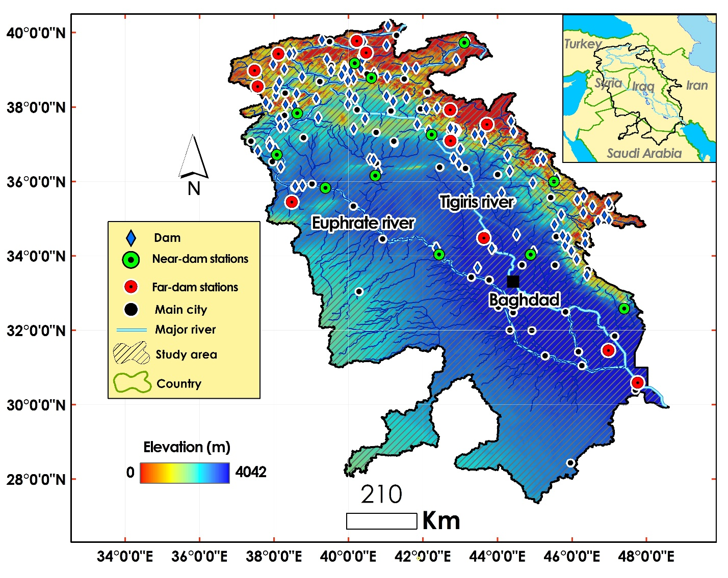

Fig. 1. The Tigris and Euphrates Basins (TEB). The operated dams, sampled near- dam and far-dam stations have been shown.

**3. Data**

The spatial distribution of significant dams in TEB is presented in Fig. 2. Important dam characteristics, including year of construction, volume, and operation, are shown in Table 1. Those were extracted from the Global Reservoir and Dam Database (GRanD). GRanD has been developed and updated with the aim of collecting information on reservoirs and dams with a storage capacity of more than 0.1 km (Lehner et al., 2011). Additionally, this study utilized two primary datasets including daily discharge and monthly Palmer Drought Severity Index (PDSI) covering the period from 1979 to 2022 to analyze discharge changes and the influence of damming and climate:

**Daily Discharge:** The available gridded daily discharge dataset provides a modeled time series of river network discharges, generated with the help of the open-source hydrological model LISFLOOD with daily time resolution. LISFLOOD is a precipitation and runoff routing model used for water and climate studies, as well as flood and drought modeling and forecasting (Harrigan et al., 2020). Daily streamflow measurements were collected from 24 key sampled stations located on the Tigris and Euphrates rivers. 12 of these stations were strategically selected for their close proximity to major dams in TEB, allowing for the assessment of the immediate impacts of dam operations. The remaining 12 stations were located at a significant distance downstream from these dams to capture the effects of other factors, such as climate variability and tributary inflows. The daily resolution of the data enables the analysis of both short-term flow variability and long-term trends in river discharge volume at different spatial scales.

**Monthly Palmer Drought Severity Index (PDSI):** Monthly PDSI values for the geographical area encompassing TEB were obtained. The PDSI is a widely recognized and used index based on the soil-water balance equation that integrates temperature, precipitation, and potential evapotranspiration to provide a standardized measure of drought severity and duration (Abatzoglou et al., 2018; Dai, 2011). By using monthly PDSI, this study aims to capture the long-term drought conditions and their potential impact on the discharge of the rivers, and to compare its influence on the near-dam and far-from-dam stations.

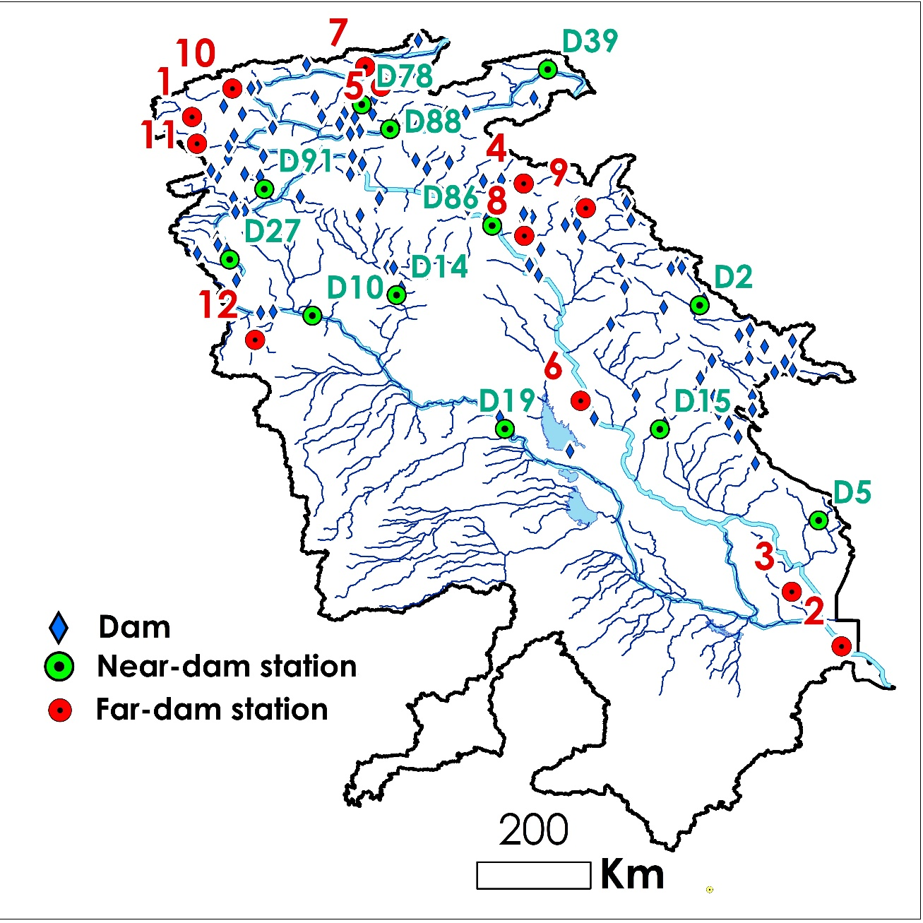

Fig. 2. Spatial distribution of the dams, sampled stations in near-dam and far-from-dam within TEB.

Table 1- The attributes of the selected dams in TEB (Lehner et al., 2011)

|  |  |  |  |  |  |  |  |  |
| --- | --- | --- | --- | --- | --- | --- | --- | --- |
| **ID** | **Code** | **Name** | **River** | **Basin** | **Country** | **Operation year** | **Functions** | **Volume (MCM[1])** |
| **1** | D19 | Haditha | Euphrates | Euphrates | Iraq | 1987 | Irrigation/ Hydro Power | 8280 |
| **2** | D39 | Yazici | Altincayir | Euphrates | Turkey | 2009 | Irrigation | 196 |
| **3** | D88 | Lower Kaleköy | Murat | Euphrates | Turkey | 2019 | Hydro Power | 516.5 |
| **4** | D27 | Karkamis | Euphrates | Euphrates | Turkey | 2000 | Hydro Power/ Flood Control | 160 |
| **5** | D91 | Sırımtaş | Birimşe | Euphrates | Turkey | 2013 | Hydro Power | 60 |
| **6** | D78 | Yedisu | Peri | Euphrates | Turkey | 2012 | Hydro Power | 5 |
| **7** | D86 | Ilısu | Tigris | Tigris | Turkey | 2018 | Irrigation/ Hydro Power/ Flood Control | 10410 |
| **8** | D10 | Baath | Euphrates | Euphrates | Syria | 1987 | Irrigation/ Hydro Power/ Flood Control | 90 |
| **9** | D14 | Bassel Al Assad | Khabur | Euphrates | Syria | 2001 | Irrigation | 605 |
| **10** | D15 | Hamrin | Diyala | Tigris | Iraq | 1981 | Irrigation/ Flood Control | 2450 |
| **11** | D2 | Sardasht | Lesser_Zab | Tigris | Iran | 2017 | Irrigation/ Hydro Power | 387 |
| **12** | D5 | Dwairej | Dwairej | Tigris | Iran | 2013 | Irrigation | 205 |

**4. Methodology**

This study focused on 12 sampling stations located in close proximity to major dams and 12 sampling stations situated at a considerable distance downstream. To investigate the discharge changes in the Tigris and Euphrates rivers and to determine the respective roles of damming and climate (drought) at different spatial scales, a combination of hydrological and statistical methods was applied to the collected datasets:

**Time Series Analysis (TSA):** The daily discharge data for both the Tigris and Euphrates rivers at the 24 sampling stations were subjected to time series analysis to identify long-term trends and patterns. Time series analysis (TSA) methods were used to detect the trend of discharge in the sampled stations. Those methods capture the relationship between a time series and its lagged values that can analyze the interdependencies among different time series (Haas et al., 2009; Shamseddin & Elmeski, 2022; Fu et al., 2024). TSA could identify the regime shifts in time series data. Breaks For Additive Season and Trend (BFAST) model decomposes elements of time series. BFAST integrates the decomposition of time series into trend, season, and residual components (Geng et al., 2019; Li et al., 2022; Mendes et al., 2022). It’s particularly effective for detecting changes within time series data. BFAST iteratively detects changes by fitting piecewise linear models to the trend component of the time series (Richter et al., 1996; Verbesselt et al., 2010; Piwowar and LeDrew, 2002). Those techniques were used to explore and quantify shifts in the average flow and temporal discharge patterns over the 44-year study period for both near-dam and far-from-dam locations. They help to understand the overall trajectory of river discharge and identifying periods of significant change at different distances from damming infrastructure.

**Correlation Analysis:** To assess the relationship between climate variability and river discharge at different locations, correlation analysis was performed between the monthly discharge data from the 24 stations and the corresponding monthly PDSI values (Nielsen, 2002; Dai, 2011). Pearson's correlation coefficient was calculated to quantify the strength and direction of the linear association between drought conditions and river flow for both near-dam and far-from-dam stations. This analysis helps to determine the extent to which drought events influence the discharge of TEB rivers at varying distances from major dams.

**Change Point Analysis:** Change point analysis was employed to detect statistically significant points in time where the mean discharge of the rivers experienced abrupt shifts at both sets of sampling stations. These identified change points were then compared with the operational timelines of major dam construction projects in the upper catchments, such as the Atatürk Dam (operational in the early 1990s) and the Ilisu Dam (began filling in 2019) (Kibaroglu & Scheumann, 2013). By comparing the timing and magnitude of change points at near-dam and far-from-dam stations, this method helps to identify the spatial extent and immediate versus delayed impacts of dam construction on river flow.

**Comparison of Pre- and Post-Damming Periods:** To quantify the impact of damming on the rivers' flow regimes at different spatial scales, the average discharge and seasonal flow patterns were compared between distinct periods: before the operation of major dams and after their significant operational phases. This comparison was conducted separately for the 12 near-dam stations to assess the differential impacts of damming on discharge depending on the distance from the dams.

**Differential Analysis of** **Near-Dam** **and Far-From-Dam Stations:** Finally, a comparative analysis was conducted between the discharge patterns observed at the near-dam stations and the far-from-dam stations for the same time periods. This involved comparing the magnitude of discharge reduction, changes in seasonal flow variability, and the strength of correlation with the PDSI between the two groups of stations. This differential analysis aimed to isolate the localized impacts of damming from the broader regional influences of climate change.

Those above methodologies collectively provide a robust framework for analyzing the complex interactions between damming, climate change, and the discharge of the Tigris and Euphrates rivers over the study period, while also accounting for the spatial variability of these impacts through the use of near-dam regarding timelines of dam constructionand far-from-dam sampling stations.

**5. Results**

**Annual discharge and drought changes**

Fig. 3 and Fig. 4 illustrate annual changes of discharge (m3/s) and drought for both near-dam and far-from-dam stations during 1979 to 2022, respectively. PDSIs were categorized in 8 classes from extremely drought (highest red vertical dash line) to extremely wet (highest blue vertical dash line) and PDSIs between -1 and 1 were ignored.

|  |  |
| --- | --- |
|  |  |
|  |  |
|  |  |
|  |  |
|  |  |
|  |  |

Fig. 3. Annual discharge (m3/s) and PDSI changes of near-dam points during 1979 to 2022. PDSIs were categorized in 8 classes from extremely drought (highest red vertical dash line) to extremely wet (highest blue vertical dash line). The operation year of dams are distinguishable in plots.

|  |  |
| --- | --- |
|  |  |
|  |  |
|  |  |
|  |  |
|  |  |
|  |  |

Fig. 4. Annual discharge (m3/s) and PDSI changes of the far-from-dam stations during 1979 to 2022.

Average discharge values of near-dam stations during before and after dam constructions are compared in Fig. 5-a. Considerable reduction of discharge was observed across all those stations during second period. Variation of near-dam station discharges within the 2 periods showed an increment in average discharge fluctuation (m3/s) for most stations (Fig. 5-b).

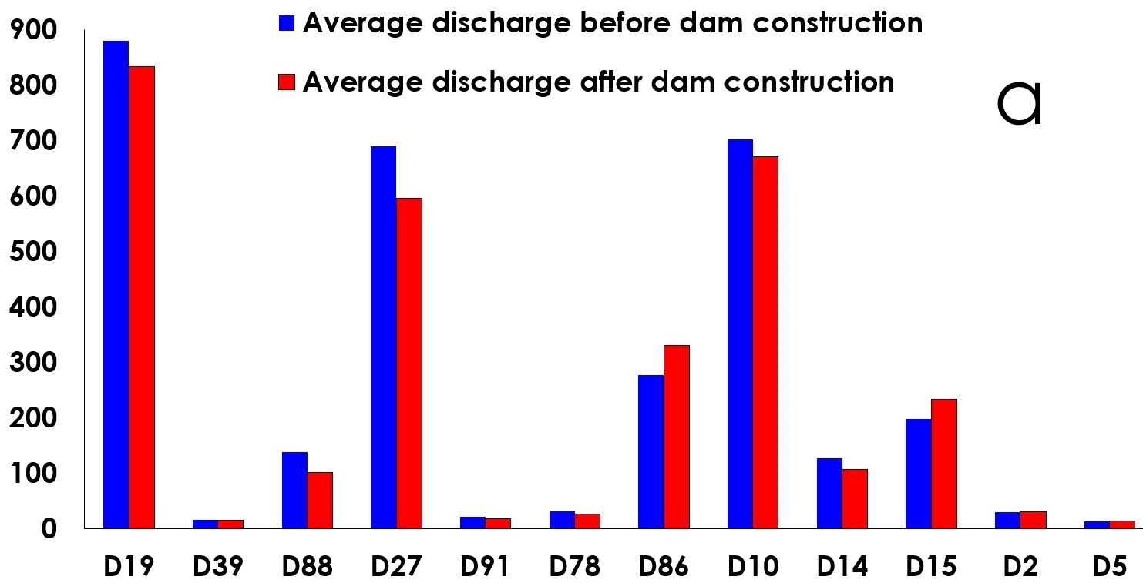

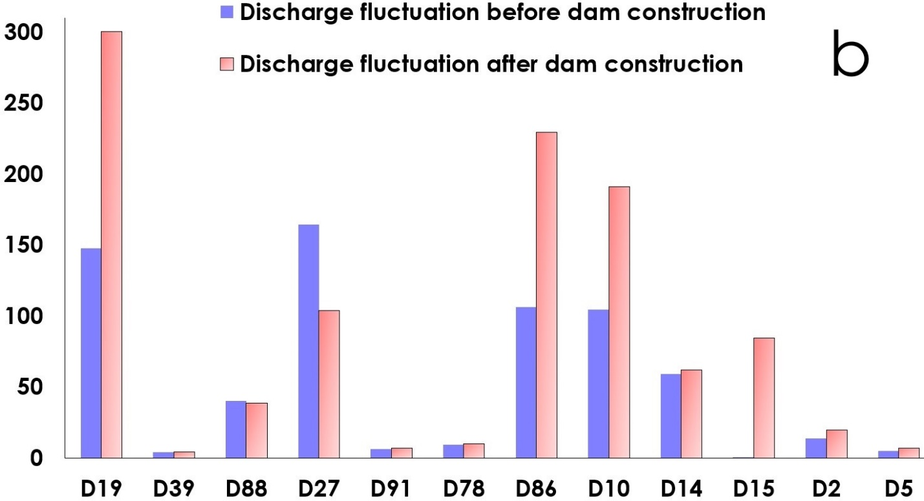

Fig. 5. Histogram illustrating the comparison of average discharge (m3/s) (a) and discharge fluctuation (m3/s) (b) of near-dam stations during before and after dam construction

**Monthly discharge trending of** **near-dam and far-from-dam stations (1979 to 2022)**

To perform flow trending, first the Mann–Kendall test was implemented on the monthly discharge series at sampled near-dam points. The two possible outcomes of the Mann–Kendall test on a time series are: with trend and non-trend. Then, trending was performed using the BFAST on the monthly discharge time series at stations with trend. Fig. 6 shows the monthly trends of near-dam stations. Fig. 7 shows the trend and seasonality components for those time series. 8 of the 12 near stations had a significant monthly flow trend between 1979 and 2022, with the exception of Bassel Al Assad dam in northeastern Syria on the Euphrates River, the remaining selected points had a decreasing monthly trend.

|  |  |  |
| --- | --- | --- |
| |  | | --- | |  | |  |
| Trend= decreasing, Slope= -0.2147 | No trend |
|  |  |
| Trend= decreasing, Slope= -0.0562 | Trend= decreasing, Slope= -0.0707 |
|  |  |
| No trend | Trend= decreasing, Slope= -0.0096 |
|  |  |
| Trend= decreasing, Slope= -0.0498 | Trend= decreasing, Slope= -0. 1561 |
|  |  |
| Trend= increasing, Slope= 0.0039 | Trend= decreasing, Slope= -0.0010 |
|  |  |
| No trend | No trend |

Fig. 6. The monthly discharge trend of the near-dam stations during 1979 to 2022 using Mann–Kendall test. For stations with trend, two parameters including Trend (increasing or decreasing) and slope were presented.

|  |  |
| --- | --- |
|  |  |
|  |  |
|  |  |
|  |  |
|  |  |
|  |  |
|  |  |

Fig. 7. Trend and seasonality components of monthly discharge trending for near-dam stations with trend.

Fig. 8 shows the monthly trends of near-dam stations during 1979 to the year of dam construction. Fig. 9 shows the trend and seasonality components of those time series. Only 2 stations including Lower Kaleköy and Ilissu, demonstrated a decreasing monthly flow trend during the period while the remaining stations had no trend. Fig. 10 presents the monthly trends of near-dam stations during the year of dam construction to 2022. 5 stations including confirmed a decreasing monthly flow trend during the studied period. Fig. 11 displays the trend and seasonality components for those monthly discharge timeseries.

|  |  |
| --- | --- |
|  |  |
| No trend | No trend |
|  |  |
| Trend= decreasing, Slope= -0.0419 | No trend |
|  |  |
| No trend | No trend |
|  |  |
| Trend= decreasing, Slope= -0.060 | No trend |
|  |  |
| No trend | No trend |
|  |  |
| No trend | No trend |

Fig. 8. The monthly discharge trend of the near-dam stations during 1979 to the year of dam construction.

.

|  |  |
| --- | --- |
|  |  |
|  |  |

Fig. 9. Trend and seasonality components of monthly discharge trending for near-dam stations with trend during 1979 to the year of dam construction.

|  |  |
| --- | --- |
|  |  |
| Trend= decreasing, Slope= -0.2234 | Trend= decreasing, Slope= -0.0525 |
|  |  |
| No trend | No trend |
|  |  |
| No trend | No trend |
|  |  |
| Trend= decreasing, slope= -2.5034 | Trend= decreasing, slope= -0.1591 |
|  |  |
| No trend | Trend= decreasing, Slope= -0.00108 |
|  |  |
| No trend | No trend |

Fig. 10. The monthly discharge trend of the near-dam stations during the year of dam construction to 2022.

|  |  |
| --- | --- |
|  |  |
|  |  |
|  |  |
|  |  |
|  |  |
|  |  |

Fig. 11. Trend and seasonality components of monthly discharge trending for near-dam stations with trend within the year of dam construction to 2022.

Fig. 12 shows the monthly trends of sampled far-dam stations during 1979 to 2022. Fig. 13 illustrates the trend and seasonality components of those time series. 10 stations verified a decreasing monthly flow trend during the period while the only 2 stations had no trend. More far-dam stations with trend compare to near- stations during the same period could imply the more uniform impact of effective factors on discharge trend in sampled far-dam stations.

|  |  |  |
| --- | --- | --- |
| |  | | --- | |  | |  |
| Trend= decreasing, Slope= -0.0002 | Trend= decreasing, Slope= -0.5163 |
|  |  |
| Trend= decreasing, Slope= -0.1591 | No trend |
|  |  |
| Trend= decreasing, Slope= -0.0037 | Trend= decreasing, Slope= -0.0863 |
|  |  |
| Trend= decreasing, Slope= -0.0077 | Trend= decreasing, Slope= -0. 0053 |
|  |  |
| No trend | Trend= decreasing, Slope= -0.0039 |
|  |  |
| Trend= decreasing, Slope= -0.0001 | Trend= decreasing, Slope= -0.0001 |

Fig. 12. The monthly discharge trend of the far-dam stations during 1979 to 2022.

|  |  |
| --- | --- |
|  |  |
|  |  |
|  |  |
|  |  |
|  |  |
|  |  |
|  |  |
|  |  |
|  |  |

Fig. 13. Trend and seasonality components of monthly discharge trending for far-dam stations with trend within 1979 to 2022.

**PSDI changes of near-dam and far-from-dam stations**

Average PDSI changes before and after dam construction, consistently shows lower (more negative) PDSI values after dam construction across all near-dam stations (Fig. 14- a), indicates an increase in drought severity downstream of the dams. Average values of PDSI for far-dam stations during 1979 to 2022 are shown in Fig. 14-b. Average PDSI of near-dam stations during 1979- 2022, before and after dam constructions were -1.3, -0.50 and -2.10, respectively, while it was -0.82 for far-dam stations. Therefore, the PDIS changes directly implies a worsening of drought conditions, especially in downstream stations of the dams after dam constructions.

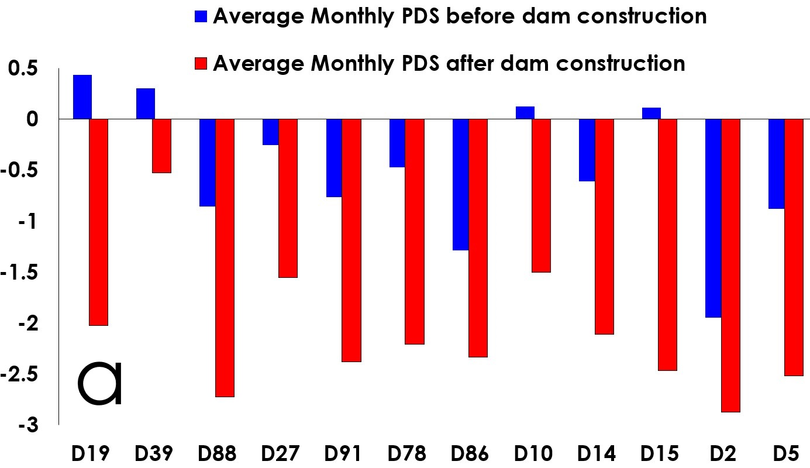

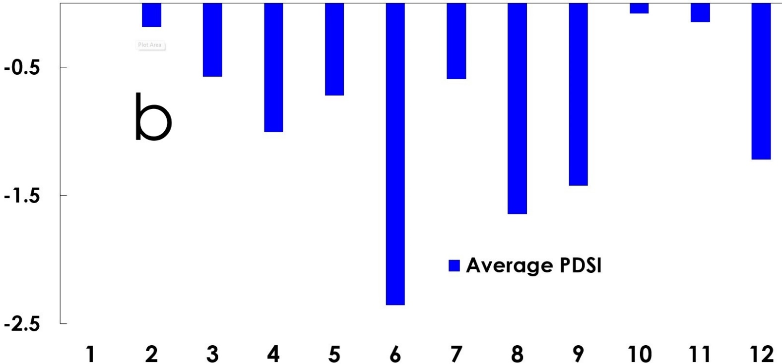

Fig. 14. Histogram illustrating the average PDSI values during before and after dam constructions for near- dam stations (a) and during 1979 to 2022 for sampled far-dam stations (b).

**Relationship between annual discharge and PDSI**

In order to measure the correlation between drought and monthly discharge, the scatter plots of the two are presented separately for near-dam stations during two periods including before and after dam constructions (Fig. 15). R2 values during before and after dam constructions are calculated for all stations and are shown for better comparison as histograms in Fig. 16. In general, the correlation between PDSI and discharge in the period after construction of dams were higher than before. The only exception is the Sırımtaş station in the northwest of TEB because less sensitivity of discharge to climatic and drought conditions, so that the correlations in the two periods did not differ much from each other. Stations with sensitivity to drought show greater correlation between discharge and drought after dam constructions.

The scatter plots and the correlation between the monthly drought and discharge of far- dam stations, during the period 1979 to 2022 are given (Fig. 17). In general, the correlation between PDSI and monthly discharge for stations 1, 10, 11, and 12, which are located in the northwest of TEB, are higher than for stations 2 and 3, which are located in the southeast of TEB. This difference is mainly due to the fact that stations 2 and 3 have a much higher average discharge than stations 1, 10, 11, and 12 (higher than 100 m3/s compare to 20 m3/s), which are less affected by meteorological drought. Therefore, correlation between discharge and drought is higher at stations with a lower average discharge, due to the higher impact of drought on discharge.

Fig. 18 demonstrates correlation between 12 values of average annual discharge and PDSI of near-dam stations during before and after dam construction as well as far-dam stations during 1979 to 2022, respectively. This cumulative attitude on relationship between those variables reveals that regression between river flow and PDSI in near-dam stations is noticeably higher than it in far-dam stations (R2 values of near and far-dam stations during 1979 to 2022 were 0.56 and 0.52, respectively), while for near-dam stations the correlation after dam construction was more than it during before dam construction.

|  |  |
| --- | --- |
|  |  |
|  |  |
|  |  |
|  |  |
|  |  |
|  |  |

Fig. 15. The scatter plots showing the correlation between annual discharge and PDSI of near- dam stations during 1979 to the year of dam construction (in blue) and the year of dam construction to 2022 (in red). X-axis and y- axis values show the annual PDSI and discharge, respectively.

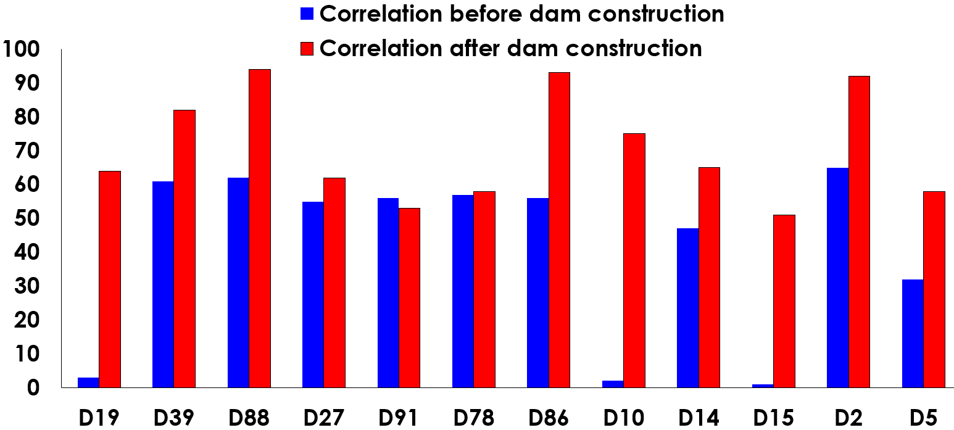

Fig. 16. Correlation between PDSI and discharge through before and after dam construction for 12 sampling near-dam stations

|  |  |
| --- | --- |
|  |  |
|  |  |
|  |  |
|  |  |
|  |  |
|  |  |

Fig. 17. The scatter plots showing the correlation between annual discharge and PDSI of the far-dam stations during 1979 to 2022.

|  |  |
| --- | --- |
|  |  |
| Fig. 18. The scatter plot showing the correlation between average annual discharge and PDSI of the near-dam stations before (in blue) and after (in red) dam construction (right) and far-dam stations during 1979 to 2022 (left). | |

**6. Discussion**

The analysis of the discharge and PDSI timeseries from 1979 to 2022, considering the differentiated sampling locations, revealed significant changes in the flow regimes of both the Tigris and Euphrates rivers, with distinct influences from damming and drought observed at near-dam and far-from-dam stations:

**Discharge Reduction:** A substantial decrease in the average discharge was observed for both rivers across all sampling stations. However, the magnitude of reduction was significantly higher at the 12 stations located near major dams, particularly after the dams became operational (Fig. 19). Far-from-dam stations also showed a reduction in discharge, but the decline was more gradual and less pronounced in the period compared to the near-dam stations (Fig. 4). A primary finding is the substantial reduction in average river flow observed at monitoring stations located downstream of dams following their construction and operation. This aligns with expectations, as dams inherently alter natural flow regimes by impounding water, regulating releases, and potentially increasing evaporative losses from reservoirs. The observed decrease in flow is a direct consequence of these activities, leading to reduced water availability downstream. The case of the Ilisu dam downstream station, showing lower flow even before impoundment (Fig. 5-a), is noteworthy and could be attributed to significant disruption of the natural river course during the prolonged construction phase, highlighting that even pre-operation activities can impact flow. The analysis of drought conditions, as indicated by the PDSI, reveals a concerning trend: drought intensity has increased at all studied near-dam stations in the period after dam construction compared to the period before. This suggests either a regional shift towards drier conditions coinciding with the operational period of the dams or a potential feedback mechanism where reduced surface water availability due to damming exacerbates localized drought impacts. The amplified reduction in river flow observed at near-dam stations during drought periods, compared to stations further away, strongly supports the notion that dams compound the effects of drought on downstream water availability.

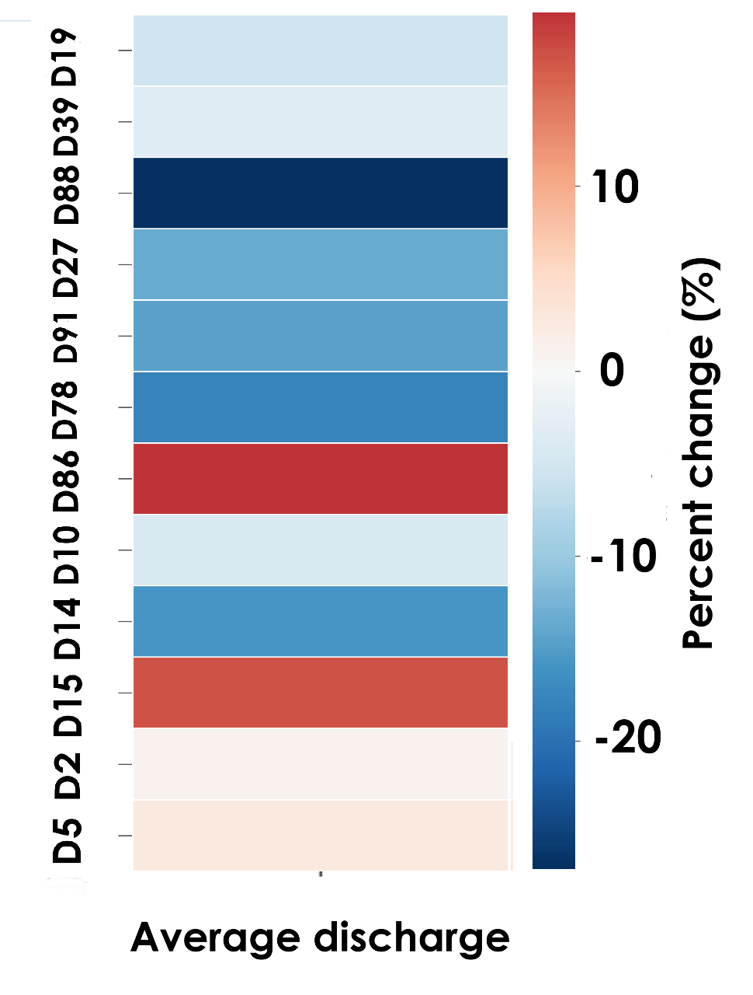

Fig. 19. Percent change in averages of discharge after dam construction for 12 sampling near-dam stations

**Varying Impact of Drought:** Correlation analysis indicated a strong positive relationship between river discharge and PDSI values at both near-dam and far-from-dam stations. However, the strength of this correlation was generally higher at the far-dam stations with a lower average discharge and near-dam stations after dam construction (Fig. 18), suggesting a greater influence of regional drought conditions on these locations due to climatic and damming factors, respectively. Near-dam stations, showed a discharge pattern more immediately responsive to dam operation schedules and with damming the impact of climate on discharge in those stations could increase and intensify.

**Alteration of Flow Patterns:** The average slope of the monthly discharge trends for far-dam stations, near-dam stations in the three periods 1979 to 2022, 1979 to the year of dam construction, and from the year of dam construction to 2022, along with the number of monthly discharges with trend, are shown in Fig. 20. The descending slope of the monthly discharge trend of near-dam points in the period after dam impoundment is greater than in the other two periods, which indicates a more decreasing trend in discharge downstream of those stations. Also, the number of monthly discharges with valid trend in the period 1979 to 2022 is greater than in the other two periods, due to the longer period of time considered, which increases the probability of being a significant trend in the monthly discharge data. Number of time series with valid trend in far-dam stations is 10 and more than near-dam stations in the same period, while the both have the similar slope.

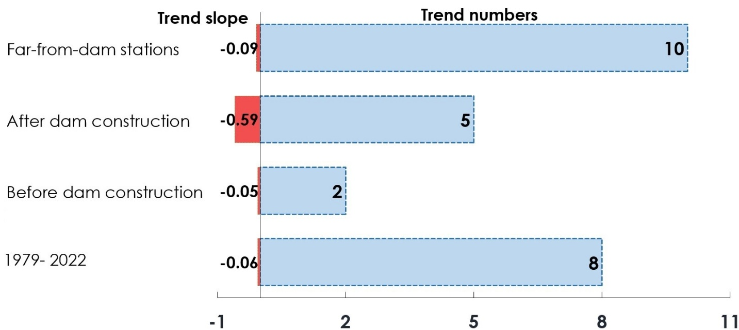

Fig. 20. Average slope and number of discharge trends in near- dam and far-dam stations

Damming projects caused a more immediate and pronounced alteration of flow patterns at the near-dam stations. These Peak flows were significantly reduced and the timing sometimes shifted shortly after dam operation commenced. Predicting and tending the seasonality of flow in downstream of these dams is more challenging. (Fig. 20). Far-from-dam stations also experienced changes in seasonality, but these changes appeared to be a combination of the integrated effects of tributary flows and regional climate patterns.

**Spatial Differences in discharge Changes:** Change point analysis identified earlier and more significant declines in the mean discharge at the near-dam stations, with change points often coinciding with the operational years of major dams. Far-from-dam stations showed change points as well, but these were sometimes delayed and the magnitude of the initial drop was less severe, suggesting a lagged and potentially buffered response to upstream damming, influenced by the cumulative effects of the basin. The estimated percentage reduction in average annual discharge during the post-damming periods was considerably higher for the near-dam stations compared to the far-from-dam stations (Fig. 20).

The pairwise correlation analysis of annual discharges of near-dam and far-dam stations further illuminates the altered hydrological landscape (Fig. 21). Fig. 21 compares average correlation values ​​of annual discharge changes. Comparing the pairwise correlation between stations near and far from dams over the entire study period (1979-2022) shows similar general behavior for both stations (Fig. 21-a and Fig. 21-b). The broader regional drought patterns affect both sets of stations. However, the more pronounced reduction in flow and the increased drought intensity specifically at the near-dam stations in the post-construction period underscore the additional, localized impact of dam operations superimposed on the regional climatic signal. The pairwise correlation among stations near dams increased after dams were constructed (Fig. 21-c and Fig. 22), suggesting relatively uniform responses to climatic forcing, while the correlations became more varied in the before-construction period (Fig. 21-d). Considering alongside the increased drought intensity and reduced flow, suggests that after damming, the flow dynamics at these stations are no longer solely dictated by localized or sub-regional climatic variations but are increasingly influenced by the regulated releases from the upstream dams, which themselves may be managed based on regional water availability dictated by climate. In essence, the dams act as a major control point, making downstream flow more uniformly dependent on the upstream management decisions and the overarching climatic conditions affecting reservoir levels. Both D15 and D2 stations have the similar location but correlation between their discharge is low particularly after dam construction because date of dam construction, functionality, and volume have been different impacts on their discharge trends. D78 and D5 stations located in northern and southern regions but as their corresponding dams were constructed in last decade of the studied period, their discharge changes have gone the similar behaviors and the correlation is higher than during before dam construction. Among far-dam stations, points 7, 9 and 12 have revealed similar discharge trends because of their positions and average discharges. While the correlation of discharge changes between stations 1 and 10, and 1 and 11 are low because different PDSIs, although their locations are similar.

|  |  |
| --- | --- |
|  |  |
|  |  |

Fig. 21. The pairwise correlation of annual discharges of near-dam (a) and far-dam (b) far-dam stations during 1979 to 2022, near-dam stations before dam construction (c), and after dam construction (d).

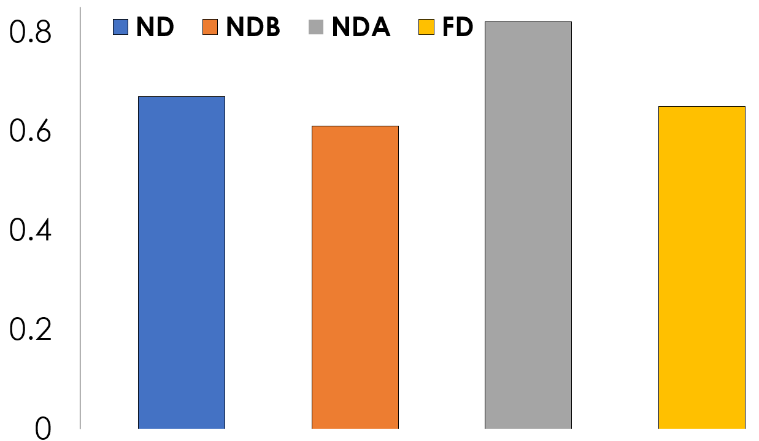

Fig. 22. Comparison of average correlation values ​​of annual discharge changes for near-dam stations during 1979 to 2022 (ND), 1979 to dam construction (NDB), dam construction to 2022 (NDA) and far-dam stations (FD)

Normalized metrics including average discharges, PDISs and their correlations for selected near-dam stations in a radar chart provides insight into the change of discharges and PDSIs and correlation between them (Fig. 23). While specific values are normalized, it allows for a visual comparison of how those might have changed before and after dam construction for selected dams. Differences between normalized discharges of 2 periods are subtle, correlation of discharge and PDSI for most stations has increased while PDSI values for all stations have decreased dramatically and their changes are more sensible. As correlation between discharges and PDSIs illuminate the changes both of them, a shift towards different correlation values after dam construction could indicate altered hydrological responses to drought.

|  |  |
| --- | --- |
|  | |
| 1 | Average discharge before dam construction |
| 2 | Average discharge after dam construction |
| 3 | Correlation of discharge and PDSI before dam construction |
| 4 | Correlation of discharge and PDSI after dam construction |
| 5 | Average PDSI before dam construction |
| 6 | Average PDSI after dam construction |

Fig. 23. Radar chart illustrating average discharges and PDISs as well as their correlations for near-dam stations thorough before and after dam construction.

The differentiated results observed at the near-dam and far-from-dam sampling stations provide a more nuanced understanding of the impacts of damming and climate change on river flow in TEB. The significantly higher discharge reductions and more immediate alterations in seasonal flow patterns at the near-dam stations strongly indicate the direct and substantial impact of dam operations on the local hydrology. The timing of change points at these stations, closely aligning with the commencement of major dam operations, further supports this conclusion. The far-from-dam stations, while also experiencing discharge reductions and altered seasonality, exhibited a more gradual decline and a strong and homogenous correlation with the PDSI, suggesting a similar influence of regional climate variability and drought conditions at these locations. The delayed and less severe initial response to damming at these downstream stations indicates that the effects of upstream flow regulation may be somewhat buffered or modified by factors such as tributary inflows and water management practices along the river course. However, the overall declining trend at these stations also underscores the cumulative impact of upstream damming across the entire basin. The findings highlight the importance of considering the spatial scale when assessing the impacts of damming on river discharge. While the immediate effects are most pronounced near the dams, the consequences extend throughout the river basin, interacting with and potentially exacerbating the impacts of climate change (Altinbilek, 2004). The observed patterns suggest that damming has created localized zones of significant hydrological alteration, while climate change exerts a more widespread influence, affecting river flow even at distances far from major damming infrastructure. These findings have critical implications for water resource management in TEB, emphasizing the need for integrated strategies that account for both the localized impacts of damming and the broader regional effects of climate change.

Fig. 24 demonstrates average discharges thorough 2 periods for near-dam stations regarding the functionality of their corresponding dams. The main types include hybrid, irrigation, and hydro power dams. Average discharge decreased after construction for all dam types. This suggests that the primary consequent of the dam is influencing of the downstream discharge patterns. Although reduction of discharge conducted by irrigation dams were more than other dams because, but the decreasing role of hydro power dams were more substantial because of their volumes.

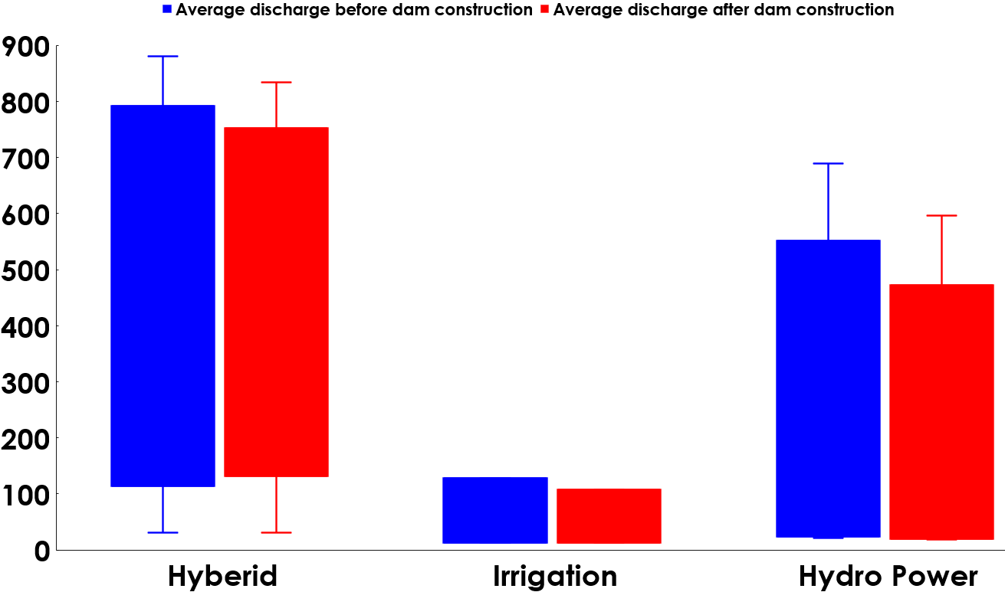

Fig. 24. Average discharge before and after dam constructions for near-dam stations regarding the dam functions

**7. Conclusion**

This study, utilized daily discharge data of near-dam and far-from-dam stations as well as monthly PDSI datasets for 1979 to 2022 period, provided a spatially differentiated analysis of the roles of damming and climate (drought) in discharge changes within the Tigris and Euphrates rivers. The findings reveal that damming has a more immediate and substantial impact on river discharge in close proximity to the dams, leading to significant reductions in flow and alterations in seasonal patterns. Climate change, as indicated by the PDSI, plays a more pervasive role across the basin. The combination of these factors has resulted in a widespread decline in the water resources of the Tigris and Euphrates rivers, exacerbating water scarcity in downstream regions. The study provided valuable insights into the complex interplay between large-scale dam construction and regional drought variability, on river flow dynamics in Tigris and Euphrates rivers. The findings clearly demonstrate that both anthropogenic alterations (damming) and natural climate phenomena (drought) exert significant, and often synergistic, influences on river discharge, particularly in arid and semi-arid environments. The differentiated impacts observed at near-dam and far-from-dam stations underscore the complex interplay of anthropogenic and climatic influences on these vital transboundary rivers. Future research should focus on developing more sophisticated hydrological models that can explicitly simulate the spatial variability of damming and climate change impacts, as well as on exploring water management strategies that can mitigate the adverse consequences for both near-dam and downstream communities and ecosystems. Collaborative efforts among the riparian countries are essential to address these challenges and ensure the sustainable management of TEB in the face of increasing water stress. In conclusion, this study provides compelling evidence that both dam construction and drought are significant drivers of reduced river flow in the study area. Their combined impact is particularly severe at locations downstream of dams, especially during periods of drought. The findings highlight the vulnerability of river systems in arid and semi-arid regions to combined anthropogenic and climatic pressures. Effective water resource management in such areas must therefore consider not only the direct impacts of infrastructure like dams but also the amplified risks posed by increasing climate variability and drought, particularly in regulating downstream flows to maintain ecological health and meet water demands. Further research could explore the specific operational rules of the dams and their influence on downstream flow variability under different drought scenarios.

**References**

Abatzoglou, J. T., Dobrowski, S. Z., Parks, S. A., & Hegewisch, K. C. (2018). TerraClimate, a high-resolution global dataset of monthly climate and climatic water balance from 1958–2015. *Scientific data*, *5*(1), 1-12.

Adamo, N., Al-Ansari, N., & Sissakian, V. (2020). How dams can affect freshwater issues in the Euphrates-Tigris basins. *Journal of Earth Sciences and Geotechnical Engineering*, *10*(1), 43-76.

Al-Ansari, N., AlJawad, S., Adamo, N., Sissakian, V. K., Laue, J., & Knutsson, S. (2018). Water quality within the Tigris and Euphrates catchments. *Journal of Earth Sciences and Geotechnical Engineering*, *8*(3), 95-121.

Al-Ansari, N., Jawad, S., Adamo, N., & Sissakian, V. (2019). Water quality and its environmental implications within Tigris and Euphrates rivers. *Journal of earth sciences and geotechnical engineering*, *9*(4), 57-108.

Altinbilek*, D. (2004). Development and management of the Euphrates–Tigris basin. *International Journal of Water Resources Development*, *20*(1), 15-33.

Azizi, M. A., & Leandro, J. (2025). Factors Affecting Transboundary Water Disputes: Nile, Indus, and Euphrates–Tigris River Basins. *Water (20734441)*, *17*(4).

Bakhtiari, M., Boloorani, A. D., Kakroodi, A. A., Rangzan, K., & Mousivand, A. (2021). Land degradation modeling of dust storm sources using MODIS and meteorological time series data. *Journal of Arid Environments*, *190*, 104507.

Beaumont, P. (1978). The Euphrates River—An international problem of water resources development. *Environmental Conservation*, *5*(1), 35-43.

Boloorani, A. D., Papi, R., Soleimani, M., Karami, L., Amiri, F., & Samany, N. N. (2021). Water bodies changes in Tigris and Euphrates basin has impacted dust storms phenomena. *Aeolian Research*, *50*, 100698.

Dai, A. (2011). Characteristics and trends in various forms of the Palmer Drought Severity Index during 1900–2008. *Journal of Geophysical Research: Atmospheres*, *116*(D12).

Eiriksdottir, E. S., Oelkers, E. H., Hardardottir, J., & Gislason, S. R. (2017). The impact of damming on riverine fluxes to the ocean: A case study from Eastern Iceland. *Water Research*, *113*, 124-138.

El‐Fadel, M., Sayegh, Y. E., Ibrahim, A. A., Jamali, D., & El‐Fadl, K. (2002). The Euphrates–Tigris Basin: A case study in surface water conflict resolution. *Journal of Natural Resources and Life Sciences Education*, *31*(1), 99-110.

Fu, Y., Zhu, Z., Liu, L., Zhan, W., He, T., Shen, H., ... & Ao, Z. (2024). Remote sensing time series analysis: A review of data and applications. *Journal of Remote Sensing*, *4*, 0285.

Geng, L., Che, T., Wang, X., & Wang, H. (2019). Detecting spatiotemporal changes in vegetation with the BFAST model in the Qilian Mountain region during 2000–2017. Remote Sensing, 11(2), 103.

Graf, W. L. (2006). Downstream hydrologic and geomorphic effects of dams: Case studies from the United States. *Geomorphology*, *79*(3-4), 264-283.

Haas, E. M., Bartholomé, E., & Combal, B. (2009). Time series analysis of optical remote sensing data for the mapping of temporary surface water bodies in sub-Saharan western Africa. *Journal of Hydrology*, *370*(1-4), 52-63.

Harrigan, S., Zsoter, E., Alfieri, L., Prudhomme, C., Salamon, P., Wetterhall, F., ... & Pappenberger, F. (2020). GloFAS-ERA5 operational global river discharge reanalysis 1979–present. *Earth System Science Data Discussions*, *2020*, 1-23.

Hussein, O. A., & Mohamed, K. (2021). Legal Rights of International Water Resources: A Case of Tigris and Euphrates Rivers. *International Journal of Law, Government and Communication*, *6*(22), 130-137.

Issa, I. E., Al-Ansari, N. A., Sherwany, G., & Knutsson, S. (2013). Trends and future challenges of water resources in the Tigris–Euphrates Rivers basin in Iraq. Hydrology and Earth System Sciences Discussions, 10(12), 14617-14644.

Kamidis, N., Koutrakis, E., Sapounidis, A., & Sylaios, G. (2021). Impact of river damming on downstream hydrology and hydrochemistry: The case of lower Nestos River catchment (NE. Greece). Water, 13(20), 2832.

Kibaroglu, A., & Scheumann, W. (2013). Turkey's water policy and the Southeastern Anatolia Project (GAP). In *Water policy in Turkey* (pp. 1-20). Springer.

Lehner, B., Liermann, C. R., Revenga, C., Vörösmarty, C., Fekete, B., Crouzet, P., ... & Robertson, J. C. (2011). Global reservoir and dam (grand) database. *Technical Documentation, Version*, *1*, 1-14.

Li, J., Li, Z. L., Wu, H., & You, N. (2022). Trend, seasonality, and abrupt change detection method for land surface temperature time-series analysis: Evaluation and improvement. *Remote Sensing of Environment*, *280*, 113222.

Lu, X. X., & Chua, S. D. X. (2021). River discharge and water level changes in the Mekong River: Droughts in an era of mega‐dams. Hydrological Processes, 35(7), e14265.

Luan, W., Li, X., Kuang, W., Su, J., Xue, H., Zhang, K., ... & Li, G. (2025). Quantitative Assessment of the Water Stress in the Tigris–Euphrates River Basin Driven by Anthropogenic Impacts. *Remote Sensing*, *17*(4).

Mendes, M. P., Rodriguez-Galiano, V., & Aragones, D. (2022). Evaluating the BFAST method to detect and characterise changing trends in water time series: A case study on the impact of droughts on the Mediterranean climate. *Science of The Total Environment*, *846*, 157428.

Nielsen, A. A. (2002). Multiset canonical correlations analysis and multispectral, truly multitemporal remote sensing data. IEEE transactions on image processing, 11(3), 293-305.

Oktav, Ö. Z. (2017). Turkey’s water policy in the Euphrates-Tigris basin. *Environmental change and human security in Africa and the Middle East*, 239-255.

Ozguler, H., & Yıldız, D. (2020). Consequences of the droughts in the Euphrates-Tigris Basin. International Journal of Water Management and Diplomacy, 1(1), 29-40.

Petts, G. E. (1984). Impounded rivers: perspectives for ecological management. *John Wiley & Sons*.

Piwowar, J. M., & LeDrew, E. F. (2002). ARMA time series modelling of remote sensing imagery: A new approach for climate change studies. *International Journal of Remote Sensing*, *23*(24), 5225-5248.

Richter, B. D., Baumgartner, J. V., Powell, J., & Braun, D. P. (1996). A method for assessing hydrologic alteration within ecosystems. *Conservation Biology*, *10*(4), 1163-1174.

Shamseddin, M. A., & Elmeski, H. A. (2022). Mapping dynamic changes in hydrological time series using the average directional index. International Journal of River Basin Management, 20(1), 67-78.

Shiklomanov, I. A. (1997). Assessment of water resources and water availability in the world. *Comprehensive Assessment of the Freshwater Re-sources of the World*.

UN-ESCWA, B. (2013). Inventory of shared water resources in western Asia: United nations economic and social commission for western Asia. *Federal Institute for Geosciences and Natural Resources, Beirut. Lebanon*.

Unver, I. O. (1997). Southeastern Anatolia Project (GAP). *International Journal of Water Resources Development*, *13*(4), 453-484.

Zargar, A., & Abbasi Alamooti, F. (2023). The security-environmental effect of the GAP project (Turkey) on downstream countries; considerations of International Law. *Quarterly Journal of West Asian Studies (Faṣlnāmah-i Gharb-i Asiyā)*, *1*(1), 73-85.

Ward, J. V., & Stanford, J. A. (1995). Ecological connectivity in alluvial river ecosystems and its disruption by flow regulation. *Regulated rivers: research & management*, *11*(1), 105-119.

Wen, L., Rogers, K., Ling, J., & Saintilan, N. (2011). The impacts of river regulation and water diversion on the hydrological drought characteristics in the Lower Murrumbidgee River, Australia. *Journal of Hydrology*, *405*(3-4), 382-391.

Verbesselt, J., Hyndman, R., Newnham, G., & Culvenor, D. (2010). Detecting trend and seasonal changes in satellite image time series. *Remote sensing of Environment*, *114*(1), 106-115.

Voss, K. A., Famiglietti, J. S., Lo, M., De Linage, C., Rodell, M., & Swenson, S. C. (2013). Groundwater depletion in the Middle East from GRACE with implications for transboundary water management in the Tigris‐Euphrates‐Western Iran region. *Water resources research*, *49*(2), 904-914.

1. - Million cubic meter (MCM)